**Ideation Phase**

**Brainstorm & Idea Prioritization Template**

|  |  |
| --- | --- |
| Date | 30 June 2025 |
| Team ID | LTVIP2025TMID37158 |
| Project Name | Transfer Learning-Based Classification of  Poultry Diseases for Enhanced Health  Management |
| Maximum Marks | 4 Marks |

**Brainstorm & Idea Prioritization Template:**

The Brainstorm & Idea Prioritization Template is a collaborative tool used to generate and organize ideas around a specific problem or challenge. It encourages team members to think creatively, share openly, and then group and evaluate those ideas based on relevance and impact.

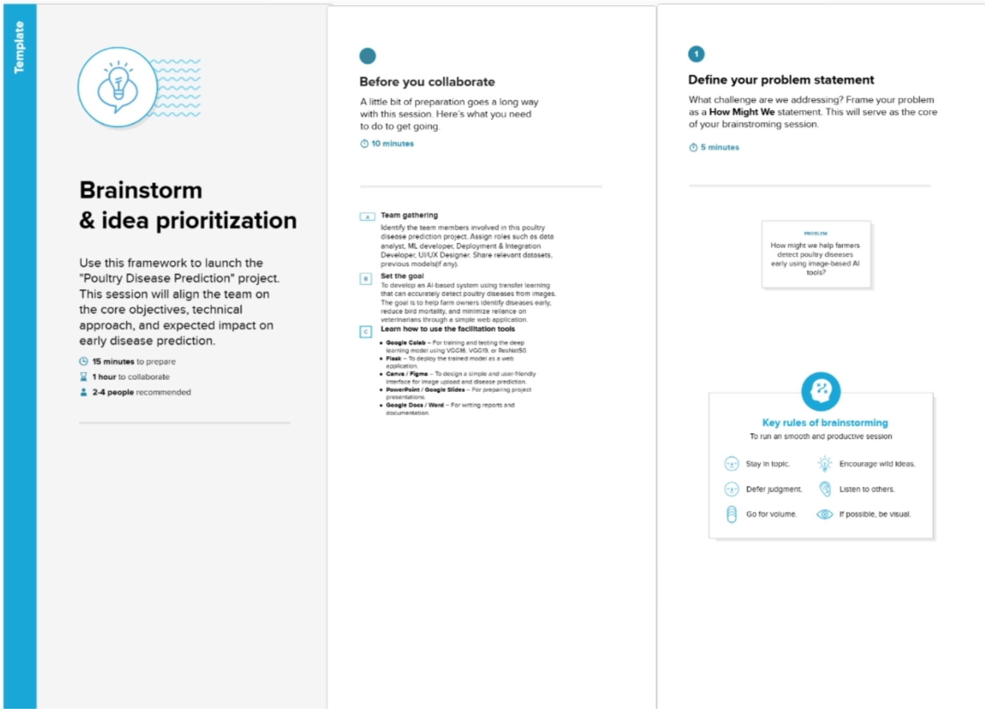

In our project, the template was used to explore innovative ideas for building an AI-based system using transfer learning to detect poultry diseases from images. Each team member contributed unique suggestions—ranging from model improvement strategies (like using VGG16 and ResNet50), data collection methods (real poultry images), and features for ease of use by farmers (voice support, local language, simple UI). These ideas were then grouped into categories such as Model Accuracy, Dataset Quality, Deployment, and Farmer Usability, and discussed as a team to select the most effective and realistic solutions.

**Step-1: Team Gathering, Collaboration and Select the Problem Statement**

**Step-2: Brainstorm, Idea Listing and Grouping**

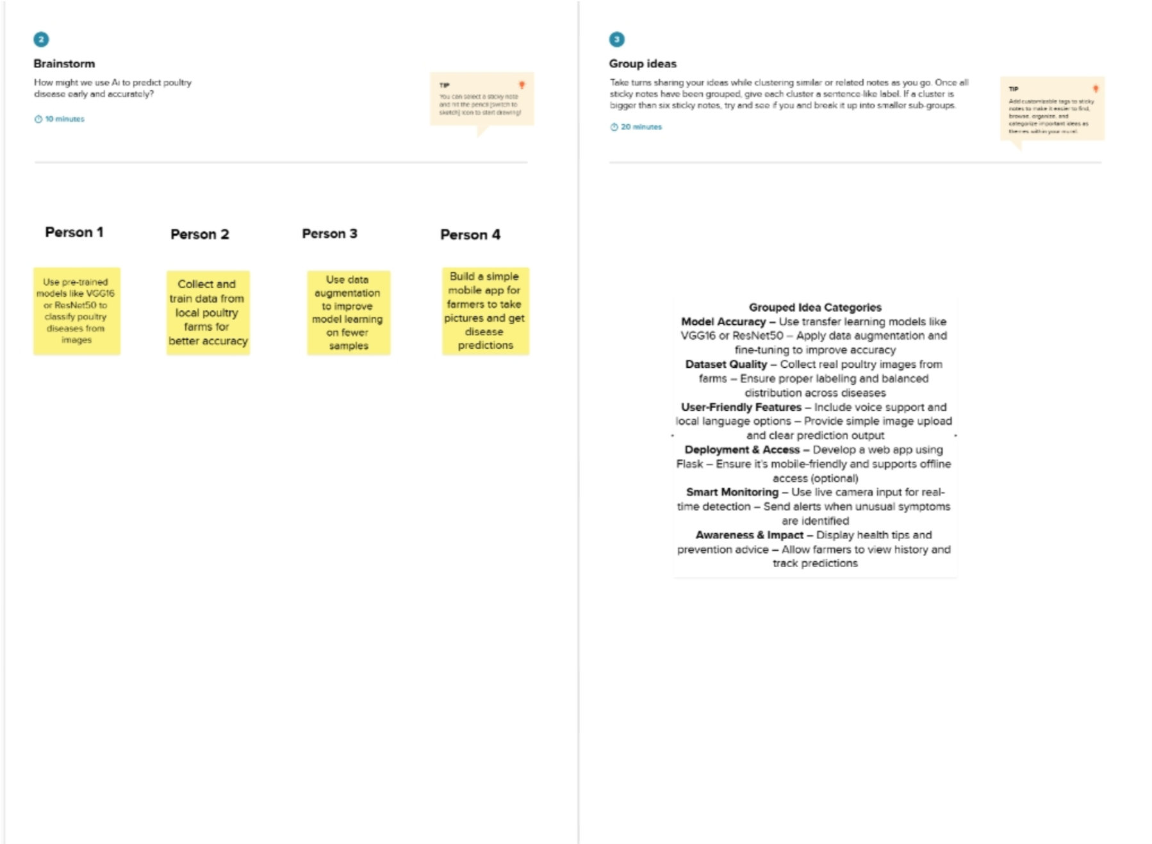

**Step-3: Idea Prioritization**

